|  |  |  |  |
| --- | --- | --- | --- |
| رقم المقعد | الفصل | رقم الجلوس | اسم الطالب |
| **37** | **1** | **33037** | **أسامه عادل السيد النحاس** |

Meeting Planer

# Overview

This project is about designing a meeting planer ,that the user can insert his meetings with its date , modify it , delete the meetings that he doesn't want and print all the stored meetings.

The structure is made by Binary search tree to sort the meetings with its date.

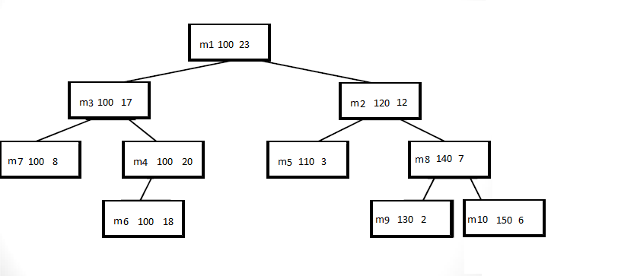

Figure 1: Binary Search Tree.

# Main Flows



Figure 2: main flow

# Modified functions in BST.

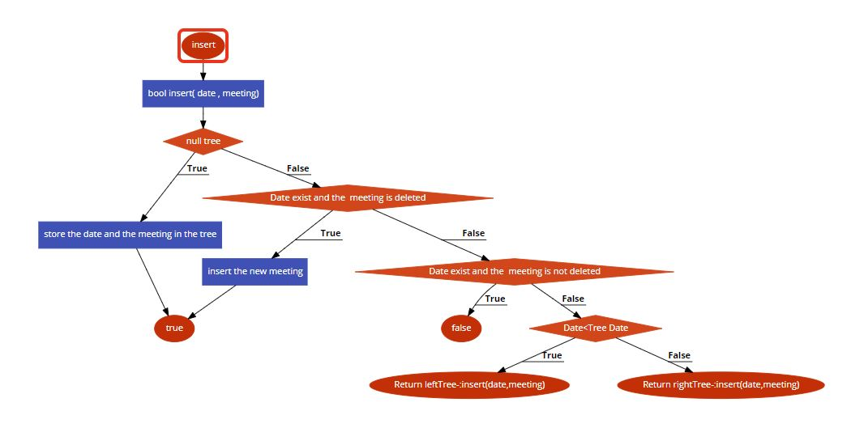

Figure 3: flow chart of insert.

I made the function returns *bool* indicates whether the insert is done or no,and stores 2 strings one for the title and the other for the date.

I compined the day and hour in one string called date eg: 02001 for day 20 and hour 1.

And add another condition to allow the insertion if the date is exist but the meeting is deleted.

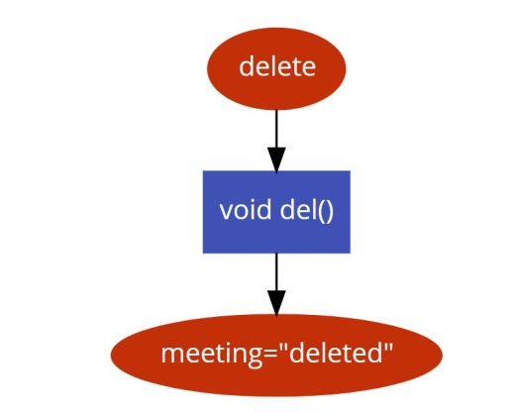

Figure 4: flow chart of delete.

Delete:changes the content of the string meeting to deleted ,to indicate that the meeting is deleted on the other functions.

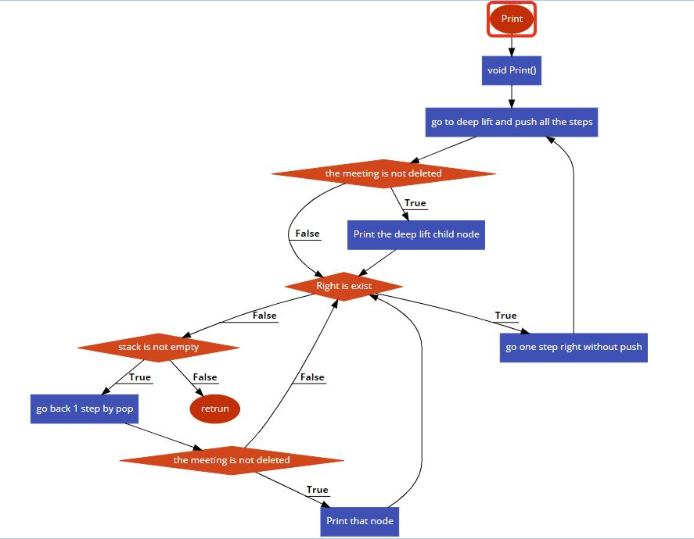

Figure 5:flow chart of Print.

Print:print all the meetings ascending by its date.

References

[1] <https://stackoverflow.com/>

[2] Lectures notes